Personal Portfolio

# Release 1

## Learning GitHub

Before I came to this class I didn’t know anything about GitHub which is what my group decided to use. So, I took the liberty to try and learn the basics of GitHub in case I was asked to perform anything on this program. I search on YouTube for simple tips and tutorials to quickly learn GitHub basics. From these tutorials I learnt that this program is a collaborative coding program that updates when another editor changes the code. Also, I found out that GitHub uses a Linux engine which I was very slightly familiar with from coding on a raspberry Pi in another class. The code was basic navigation through the system using cd and ls to change directory and list the contents of the current directory.

### YouTube Videos Referenced:

Github Tutorial For Beginners – Github Basics for mac or Windows & Source Control Basics:

<https://www.youtube.com/watch?v=0fKg7e37bQE>

Learn Git in 20 Mins:

<https://www.youtube.com/watch?v=Y9XZQO1n_7c>

## User Scenarios and Storyboards

I thought that it would be a good idea to make some user scenarios and storyboards for customers, drivers and operators of this website and show what problems could emerge and how the system will counter it.

Google Drive:

<https://drive.google.com/drive/folders/0B2tsQUI1Lpe2OHJpUm54b2pEYk0>

1. Customer lives on the east side of Brisbane and wants 2 packages delivered on an express delivery. On the spot delivery services is in the work area and is able to perform the customer’s request. The client’s packages weigh 5Kg in total and would cost $6 delivery. The customer sets the order with full details including, address, postcode, name and card details to finalise the order. A driver is sent out to pick up the packages and receive a signature to approve the delivery. The driver then checks the packages in to the warehouse to be logged into the system and then is sent off to its intended destination.
2. A customer lives in Cairns and has placed a pickup from on the spot delivery but the service doesn’t reach that area so the customer is given a notice that this service is unavailable and is recommended to try another service.

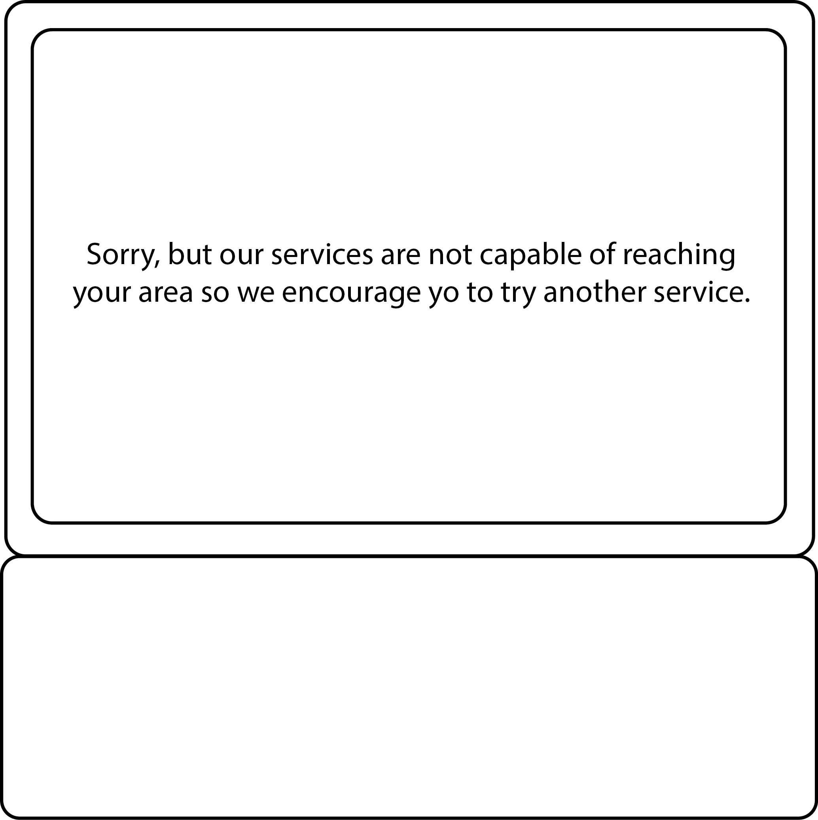

1. A customer’s package has reached the warehouse and isn’t checked in by the driver. The driver is alerted that this package wasn’t logged and is warned that it needs to be done. The driver then logs the package and the work flow continues.

|  |  |  |
| --- | --- | --- |
|  |  |  |

1. The customer database has found a double in emails for two different accounts and removes the new account to make sure that there are no recurring key details.

|  |  |  |  |
| --- | --- | --- | --- |
| Name | Email | Address | Postcode |
| Tom Jones | [email@email.com](mailto:email@email.com) | 123 One St. | 4111 |
| Tom Jones | email@email.com | 123 One St. | 4111 |
| Adam Joy | adamj@email.com | 32 Two Rd. | 4213 |

|  |  |  |  |
| --- | --- | --- | --- |
| Name | Email | Address | Postcode |
| Tom Jones | [email@email.com](mailto:email@email.com) | 123 One St. | 4111 |
| ~~Tom Jones~~ | ~~email@email.com~~ | ~~123 One St.~~ | ~~4111~~ |
| Adam Joy | adamj@email.com | 32 Two Rd. | 4213 |

|  |  |  |  |
| --- | --- | --- | --- |
| Name | Email | Address | Postcode |
| Tom Jones | [email@email.com](mailto:email@email.com) | 123 One St. | 4111 |
| Adam Joy | adamj@email.com | 32 Two Rd. | 4213 |

## Database Design Schema

For the first release we focused on the customer’s aspect to the website so I was given the job to create a basic database design for release 1. Although this release was only for customers, I linked the whole system into on schema.

Schema:

<https://drive.google.com/drive/folders/0B2tsQUI1Lpe2a3pUU0EzZEpqYkE>

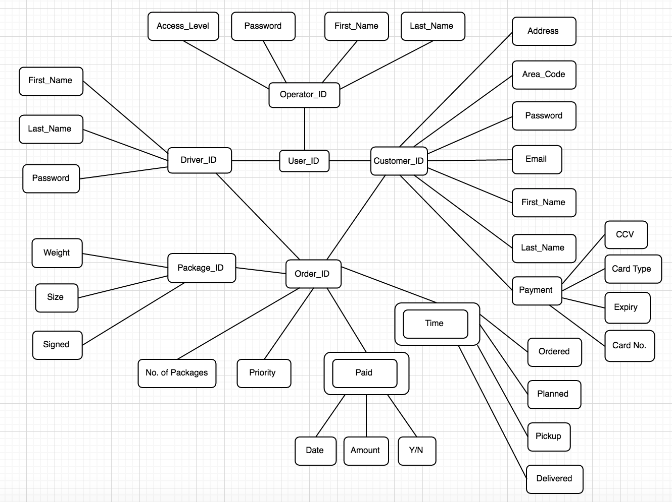

## User Feedback

My group all thought it would be a good idea to get some outsider feedback on our release 1 website. I asked one of my parents and a friend to see what they thought was good and if improvements were needed. The feedback given was useful and was taken into account for future updates.

Sprint 1 & 2 Feedback:

<https://drive.google.com/drive/folders/0BwP2kPDcz6O9M2tkUGtkN1Bfb2M>

**On the Spot Delivery Website User Feedback Form 1.0**

|  |  |
| --- | --- |
| Release: | 1 |
| Sprint: | 2 |
| Date of Test: | 16/9/2016 |
| Customer Segment *(Highlight applicable)* | Manager / Driver / Customer |
| Age Group *(Highlight applicable)* | 18-25 / 26-45 / 46-65/ 66+ |
| Gender: | Male |
| Equipment Used in Test: | Laptop |
| Have you had any previous experience with any online shipping portals? | Yes, I have used EBay and Amazon |

**User Impressions:** *Rate from 1 (Worst Possible) to 10 (Best Possible)*

|  |  |
| --- | --- |
| Ease of Use | 9 |
| Design | 8 |
| Reliability | 7 |
| Performance | 9 |
| Overall Rating | 9 |

**User General Feedback:**

*Do you have any recommendations for future releases or any feedback you would like to give?*

*I don’t have any recommendations for how the website could run better. The service was smooth and clean.*

**Tester Comments:**

*Were there any technical difficulties during the test?*

*Were there any issues or suggestions you have for future releases based on your observations of the user?*

*No there weren’t any problems.*

*I liked the way the website looked. It was balanced but I would recommend trying some different colour variation for the design. Otherwise everything was great.*

**On the Spot Delivery Website User Feedback Form 1.0**

|  |  |
| --- | --- |
| Release: | 1 |
| Sprint: | 2 |
| Date of Test: | 16/9/2016 |
| Customer Segment *(Highlight applicable)* | Manager / Driver / Customer |
| Age Group *(Highlight applicable)* | 18-25 / 26-45 / 46-65/ 66+ |
| Gender: | Male |
| Equipment Used in Test: | Laptop |
| Have you have any previous experience with any online shipping portals? | Yes |

**User Impressions:** *Rate from 1 (Worst Possible) to 10 (Best Possible)*

|  |  |
| --- | --- |
| Ease of Use | 8 |
| Design | 9 |
| Reliability | 8 |
| Performance | 8 |
| Overall Rating | 8 |

**User General Feedback:**

*Do you have any recommendations for future releases or any feedback you would like to give?*

*I would recommend introducing a basic pricing table of some sort to help customers estimate what they will be paying.*

**Tester Comments:**

*Were there any technical difficulties during the test?*

*Were there any issues or suggestions you have for future releases based on your observations of the user?*

*The were no problems when testing.*

*There weren’t any issues that I found, the whole website so far is pretty good.*

## Business Letter Research

My team didn’t know much about writing formal business letters so I search online for some examples of formal business letters to help us write for the first peer review. These 2 sites helped me understand what was required for the peer review.

Research:

The Writer’s Handbook:

<http://writing.wisc.edu/Handbook/BusinessLetter.html>

Writing a business letter:

<http://auspost.com.au/education/letterwriting/students/business-letters.html>

# Release 2

## Database Design

For this release we focused on the driver and operator aspects of the system. I had to change some links and tables of the previous database schema because the client and the code changed over the previous sprints. Tables like the Check-in, Pick-Up and Delivered tables were added and linked to the order table. These tables were based on the columns that were in the websites code.

Database Design & Database Tables Code: <https://drive.google.com/drive/folders/0B2tsQUI1Lpe2a3pUU0EzZEpqYkE>

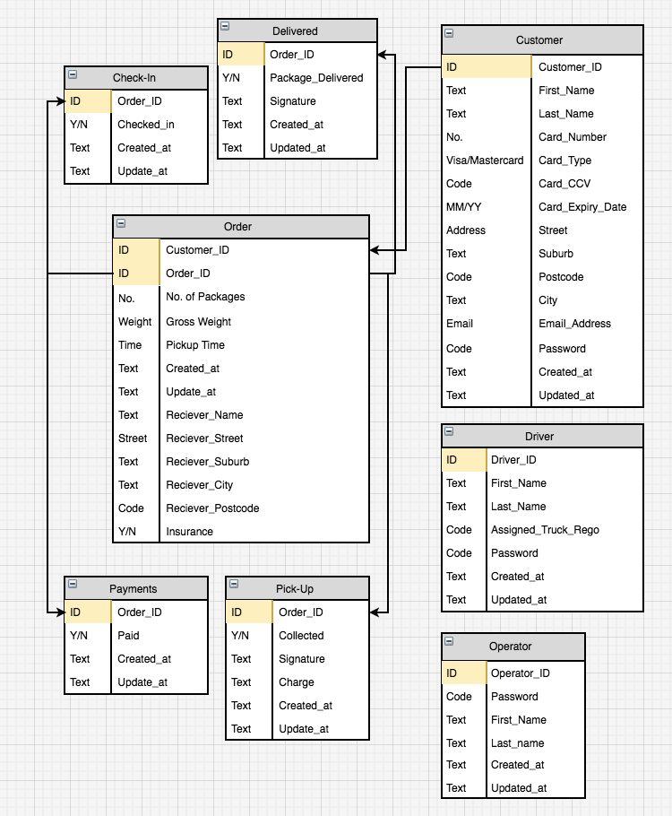

## JIRA Input and Release 2 Document Updates

In release 2 we introduced some new user story subtasks that weren’t on the JIRA repository so I went ahead and made sure that these sub tasks were on the allocated user story. If the sub tasks weren’t there I added them in to both the release 2 document and the repository itself. I chose 2 user stories to change/add.

Release 2 Document:

<https://drive.google.com/drive/folders/0B9zwO_EMVPbiZ3hQcVNjYl8zSDA>

## Story ID: SRCX-42 Title: Operator Management Page

|  |  |  |  |  |
| --- | --- | --- | --- | --- |
| **Task ID** | **Task Description** | **Assignee** | **Estimate** | **Taken** |
| **SRCX-186** | Create static Operator page | Michael Leontieff-Smith | 2 hours | 2 hours |
| **SRCX-187** | Implement Sidebar partial | Michael Leontieff-Smith | 3 hours | 3 hours |
| **SRCX-188** | Create Route | Michael Leontieff-Smith | 1 hour | 1 hour |
| **SRCX-189** | Register page within Operators Controller | Michael Leontieff-Smith | 1 hour | 1 hour |
| **SRCX-190** | Implement session checking methods for authorisation | Michael Leontieff-Smith | 3 hours | 4 hours |
| **SRCX-191** | Acceptance Testing | Amos Fox | 2 hours | 2 hours |
| **SRCX-192** | Production Deployment | Michael Leontieff-Smith | 1 hour | 1 hour |
|  | Story Points: 2 |  | 13 hours | 14 hours |

## Story ID: SRCX-96 Title: Order Confirmation Prompt

|  |  |  |  |  |
| --- | --- | --- | --- | --- |
| **Task ID** | **Task Description** | **Assignee** | **Estimate** | **Taken** |
| **SRCX-193** | Research development approaches | Michael Leontieff-Smith | 4 hours | 4 hours |
| **SRCX-117** | Import JQuery Libraries | Michael Leontieff-Smith | 1 hour | 2 hours (issues with rails) |
| **SRCX-118** | Create code snippets | Michael Leontieff-Smith | 1 hour | 1 hour |
| **SRCX-194** | Implement state process | Michael Leontieff-Smith | 1 hour | 1 hour |
| **SRCX-195** | Implement buttons to represent process | Michael Leontieff-Smith | 1 hour | 1 hour |
| **SRCX-119** | Acceptance Testing | Amos Fox | 2 hours | 2 hours |
| **SRCX-120** | Production Deployment | Michael Leontieff-Smith | 1 hour | 1 hour |
|  | Story Points: 2 |  | 11 hours | 12 hours |

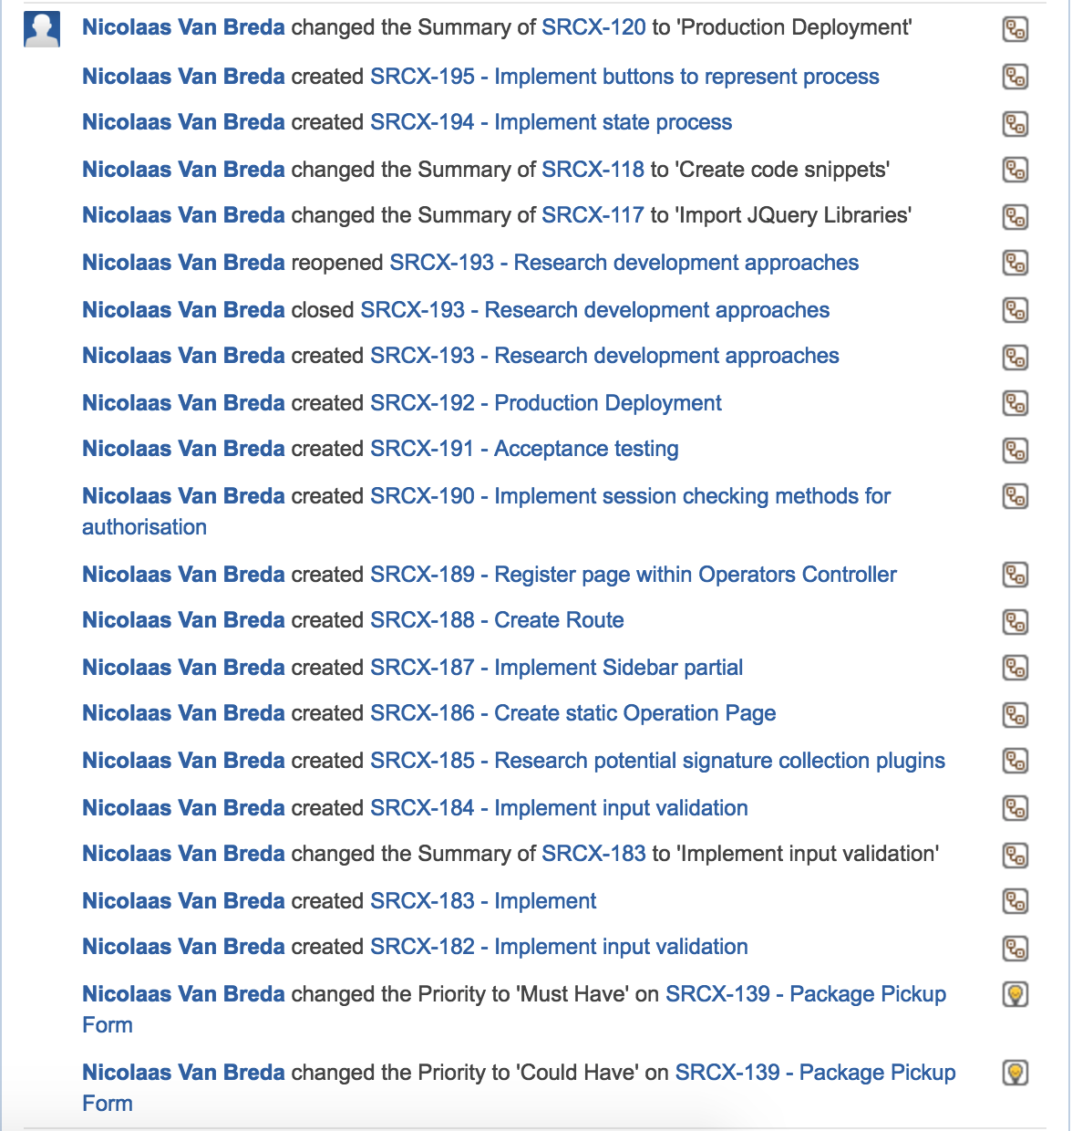

## User Feedback

I went out and asked a new family member and another friend to find out what their thoughts were for the website for release 2. The feedback would be useful for future releases and could help improve our service.

Sprint 3 & 4 Feedback:

<https://drive.google.com/drive/folders/0BwP2kPDcz6O9M2tkUGtkN1Bfb2M>

**On the Spot Delivery Website User Feedback Form 1.0**

|  |  |
| --- | --- |
| Release: | 2 |
| Sprint: | 4 |
| Date of Test: | 23/10/2016 |
| Customer Segment *(Highlight applicable)* | Manager / Driver / Customer |
| Age Group *(Highlight applicable)* | 18-25 / 26-45 / 46-65/ 66+ |
| Gender: | Male |
| Equipment Used in Test: | Laptop |
| Have you have any previous experience with any online shipping portals? | Yes |

**User Impressions:** *Rate from 1 (Worst Possible) to 10 (Best Possible****)***

|  |  |
| --- | --- |
| **Ease of Use** | **9** |
| **Design** | **8** |
| **Reliability** | **8** |
| **Performance** | **9** |
| **Overall Rating** | **8** |

**User General Feedback:**

*Do you have any recommendations for future releases or any feedback you would like to give?*

*For future release you could try and make the forms look more pleasing to look at and have the structure of the website more refined. Maybe have different colours for different users. E.g. Blue for customer, Red for drivers, etc.*

**Tester Comments:**

*Were there any technical difficulties during the test?*

*Were there any issues or suggestions you have for future releases based on your observations of the user?*

*No there weren’t any issues when I used the website.*

*As I said before, try making the forms better looking.*

**On the Spot Delivery Website User Feedback Form 1.0**

|  |  |
| --- | --- |
| Release: | 2 |
| Sprint: | 4 |
| Date of Test: | 23/10/2016 |
| Customer Segment *(Highlight applicable)* | Manager / Driver / Customer |
| Age Group *(Highlight applicable)* | 18-25 / 26-45 / 46-65/ 66+ |
| Gender: | Male |
| Equipment Used in Test: | Laptop |
| Have you have any previous experience with any online shipping portals? | Yes, Amazon. |

**User Impressions:** *Rate from 1 (Worst Possible) to 10 (Best Possible)*

|  |  |
| --- | --- |
| Ease of Use | 8 |
| Design | 8 |
| Reliability | 8 |
| Performance | 8 |
| Overall Rating | 8 |

**User General Feedback:**

*Do you have any recommendations for future releases or any feedback you would like to give?*

*No I don’t have any recommendations for this website, the manager screens seem to be working fine with everything on the screen being relevant. So overall I think it was good.*

**Tester Comments:**

*Were there any technical difficulties during the test?*

*Were there any issues or suggestions you have for future releases based on your observations of the user?*

*There weren’t any problems.*

*I don’t think there is need for improvement, this website has all the features it needs for the managers to operate the business.*

## Basic Final Website Testing

Before the final checks for the website on sprint 4, I went on and tested some basic validation and processes to make sure the website still worked. Luckily there weren’t any glitches to take note of.